Institute of Computer Technology

B. Tech Computer Science and Engineering

Subject: DS (2CSE302)

**PRACTICAL-4**

**AIM: - Ankit is a 5-year-old kid, who is playing in a boardroom with a basket and bolls. Each boll is having numbered on it like 1, 2, 3…….upto 9. Ankit’s aunt asked him to put all boll inside the basket. Here, the scenario is that basket is long enough to hold all boll but squeezed in width and can hold only one boll at a time. When the next boll is inserted, then that boll can lie on top of the old boll like this way.**

**a). Write a c program to perform the following operation onto the basket:**

**• Push boll numbered as 1 inside the basket**

**• Push boll numbered as 8 inside the basket**

**• Push boll numbered as 9 inside the basket**

**• Push boll numbered as 7 inside the basket**

**• Push boll numbered as 2 inside the basket**

**• Pop boll from the basket**

**• Pop boll from the basket**

**• Push boll numbered as 3 inside the basket**

**Display the bolls present in the basket/stack.**

***SOLUTION***

#include <stdio.h>

#include <stdlib.h>

int Top=-1,YashPra[9];

int size=8;

void PushNum()

{

int x;

if(Top==size)

{

printf("\nOverflow!\n");

}

else

{

printf("\nEnter number of ball to be inserted: ");

scanf("%d",&x);

Top=Top+1;

YashPra[Top]=x;

}

}

void PopNum()

{

if(Top==-1)

{

printf("\nEmpty!\n");

}

else

{

printf("\nPopped ball numbered: %d",YashPra[Top]);

Top=Top-1;

}

}

void show()

{

if(Top==-1)

{

printf("\nEmpty!\n");

}

else

{

printf("\nBalls in stack array are:\n");

for(int i=Top;i>=0;--i)

{

printf("%d\n",YashPra[i]);

}

}

}

int main()

{

int ch;

while(1)

{

printf("\n(1) PUSH Ball");

printf("\n(2) POP Ball");

printf("\n(3) Show Stack");

printf("\n(4) Exit");

printf("\nEnter your choice: ");

scanf("%d",&ch);

switch(ch)

{

case 1:

PushNum();

break;

case 2:

PopNum();

break;

case 3:

show();

break;

case 4:

exit(0);

default:

printf("\nInvalid Choice Entered\n");

break;

}

}

return 0;

}

***OUTPUT***

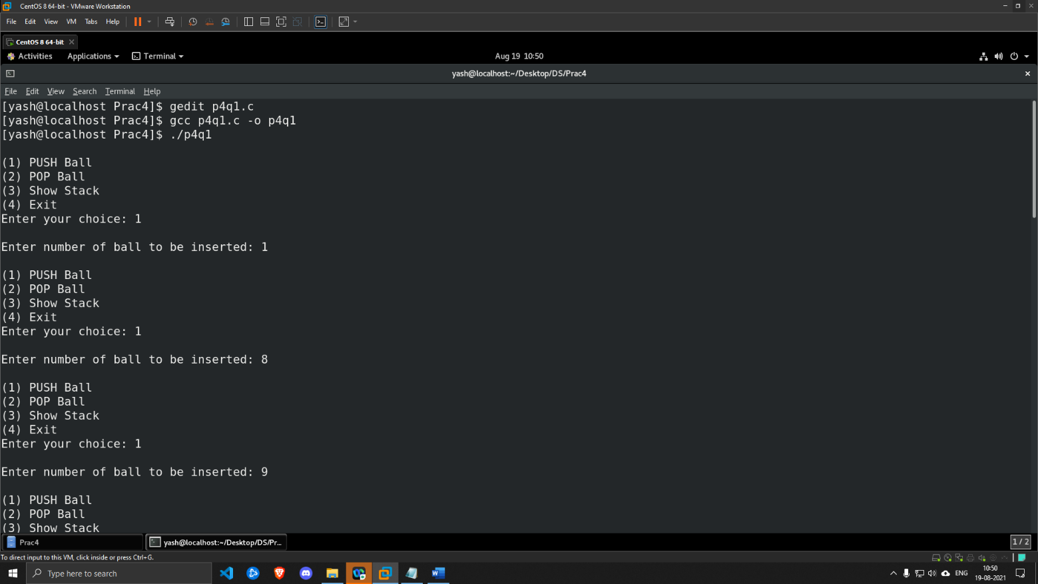

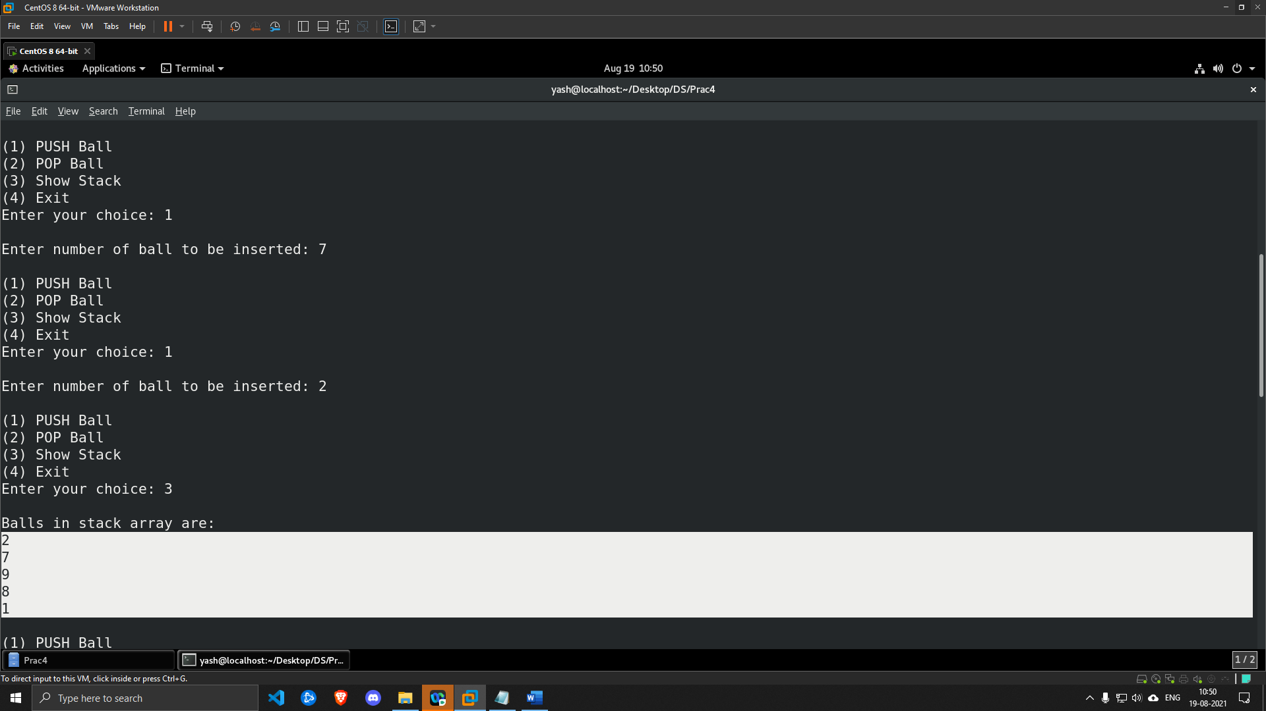

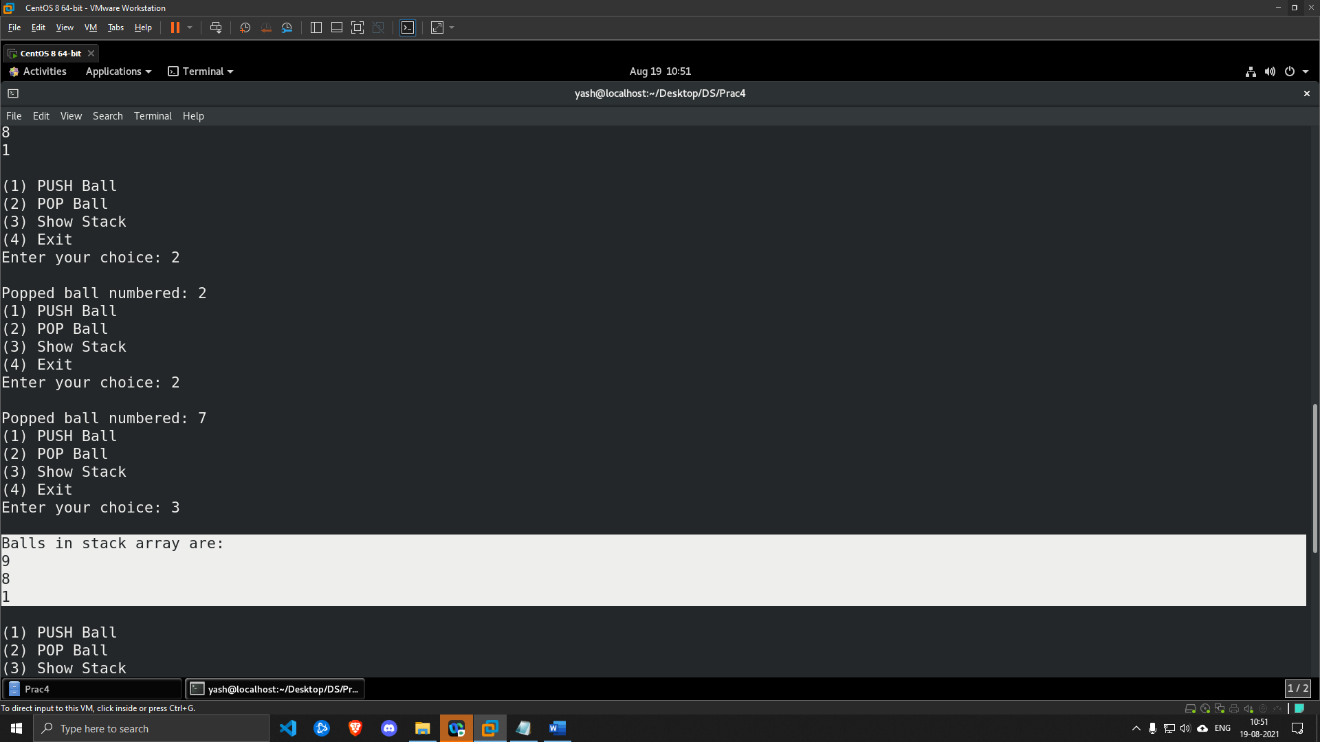

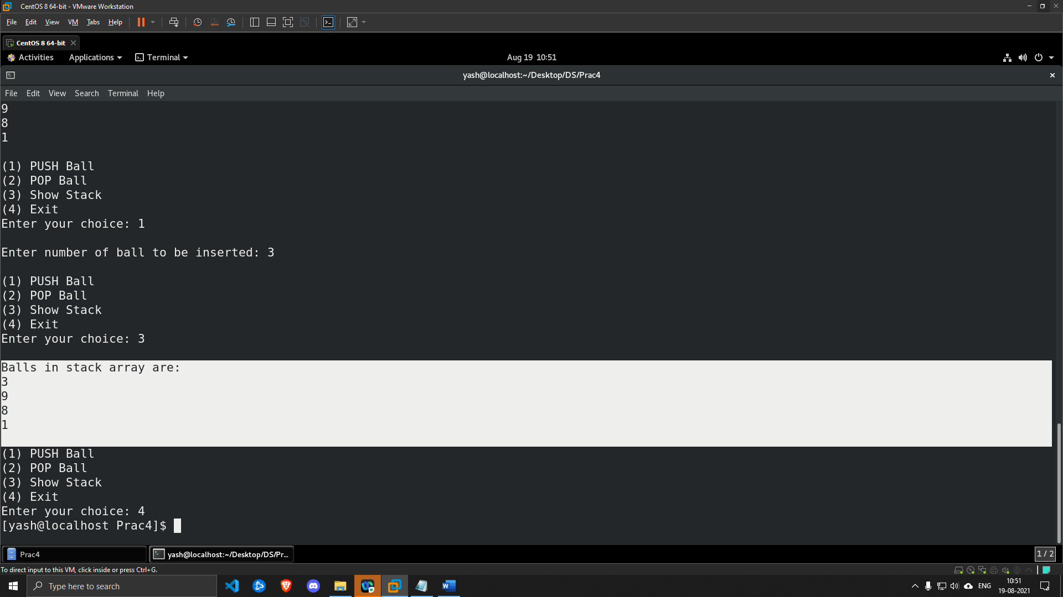

**b). Ankit stores the boll randomly (1,8,9,3 from previous question 4.a) but Ankit's aunt asked him to store odd-numbered (1,3,5,7,9) boll first and then even number boll (2,4,6,8). Ankit should start from boll numbered as 1 then should push boll numbered as 2, then 3, and so on. Once all bolls have been pushed then print all elements. Write a c program to perform the following operation onto the basket:**

* **Pop boll from the basket**
* **Pop boll from the basket**
* **Pop boll from the basket**
* **Push boll numbered as 2 inside the basket**
* **Push boll numbered as 3 inside the basket**
* **Push boll numbered as 4 inside the basket**
* **Push boll numbered as 5 inside the basket**
* **Push boll numbered as 6 inside the basket**
* **Push boll numbered as 7 inside the basket**
* **Push boll numbered as 8 inside the basket**
* **Push boll numbered as 9 inside the basket**

**Display the bolls present in the basket/stack.**

**Hint: Maxsize of stack = 9**

***SOLUTION***

#include <stdio.h>

#include <stdlib.h>

int Top=-1,YashPra[9];

int size=8;

void PushNum()

{

int x;

if(Top==size)

{

printf("\nOverflow!\n");

}

else

{

printf("\nEnter number of ball to be inserted: ");

scanf("%d",&x);

if(Top==-1)

{

Top=Top+1;

YashPra[Top]=x;

}

else if(x>YashPra[Top] && YashPra[Top]%2==1 )

{

Top=Top+1;

YashPra[Top]=x;

}

else if(x>YashPra[Top] && YashPra[Top]%2==0 )

{

Top=Top+1;

YashPra[Top]=x;

}

else

{

printf("\nCannot PUSH %d as condition not satisfied\n",x);

}

}

}

void PopNum()

{

if(Top==-1)

{

printf("\nEmpty!\n");

}

else

{

printf("\nPopped ball numbered: %d",YashPra[Top]);

Top=Top-1;

}

}

void show()

{

if(Top==-1)

{

printf("\nEmpty!\n");

}

else

{

printf("\nBalls in stack array are:\n");

for(int i=Top;i>=0;--i)

{

printf("%d\n",YashPra[i]);

}

}

}

int main()

{

int ch;

Top=Top+1;

YashPra[Top]=1;

Top=Top+1;

YashPra[Top]=8;

Top=Top+1;

YashPra[Top]=9;

Top=Top+1;

YashPra[Top]=3;

while(1)

{

printf("\n(1) PUSH Ball");

printf("\n(2) POP Ball");

printf("\n(3) Show Stack");

printf("\n(4) Exit");

printf("\nEnter your choice: ");

scanf("%d",&ch);

switch(ch)

{

case 1:

PushNum();

break;

case 2:

PopNum();

break;

case 3:

show();

break;

case 4:

exit(0);

default:

printf("\nInvalid Choice Entered\n");

break;

}

}

return 0;

}

***OUTPUT***

